Healthy Workspaces

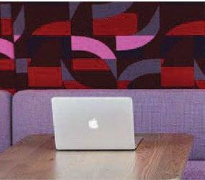  Luum creates design-driven, performance-oriented woven and coated fabrics for the modern interior. Our knowledge of weaving and innovative technology allows us a unique perspective into the design process, creating well-crafted and intentional products in beautiful colorways and textures not seen elsewhere. | In today’s unprecedented time, we understand there are new challenges for hygiene and safety in the workplace. Luum’s goal is to provide information on our products to help you educate your clients on the safest and most effective ways to care for textiles.  As such, Luum does not promote the use of topical antimicrobial finishes as these products do not kill the COVID-19 virus. They are only intended to inhibit the growth of bacteria and other microbes. Antimicrobial finishes can be harmful to human health and the environment alike.  We encourage prevention and perspective while maintaining a healthy workplace. Cleaners such as soap and water in conjunction with household disinfectants like bleach can be effective against the spread of viruses. Maintain perspective and clean “high touch” surfaces first.  Cleaners  Cleaning products remove germs, dirt and impurities from surfaces using soap (or detergent) and water. Cleaning does not necessarily kill germs, but by removing them, it lowers their numbers and therefore the risk of spreading infection.  Disinfectants  As per the CDC, “Disinfectants kill germs on surfaces. By killing germs on a surface after cleaning, you can further lower the risk of spreading infection. EPA-approved disinfectants are an important part of reducing the risk of exposure to COVID-19”. Further information regarding cleaners and disinfectants can be found on the Centers for Disease Control and Health Canada websites.  Many of Luum’s 30+ bleach and/or viricide cleanable and 30+ bleach cleanable and  80+ isopropyl alcohol sanitizable are made for vertical and upholstery application and feature plush piles and textural dimension, which can be utilized in a variety of settings  with assurance of performance.  Each fabric has unique cleaning and care instructions. For more information, please refer to the Luum website filters and resources page at luumtextiles.com. For further questions or assistance identifying textiles, contact Luum Customer Service at 1-877-705-5886 or email us a customerservice@luumtextiles.com. For textile applications on products please refer to manufacturers’ approvals.
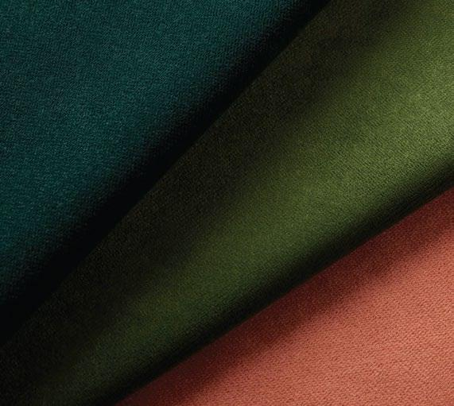  Velvet Underground | Soap and Water Cleanable  Luum recommends following the CDC guidelines for regular preventative cleaning. Look for Luum’s over 80 products with cleaning code “W” and/or “WS”: these fabrics can be cleaned with soap and water.  Multipurpose (Upholstery/Wrapped Wall/Panel)  Actuate, Biotope, Bitstream, Complect, Complement, Cross Dye, Crossgrain, Cult Classic, Digi Tweed, Ecotone, Formwork, Ghat, Graviton, Grid State, Heather Tech, High Frequency, Intone, Intraweb, Limitless Loop, Marl Cloth, Megacheck, Percept, Texture Map, Twisted Tweed  Upholstery  Amalgam, Ample, Arc Angle, Beaded Stripe, Color Fuse, Crossdye, Disrupt, Doyenne, Duo Chrome, Ephemera, Fine Grain, Flexagon, Flex Wool, Fundamentals, Geoglyph, Haptic, Heather Felt, Line Language, Magnify, Meta Texture, Miami, Milieu, Modulus, Monotex, Navigate, Outpress, Particulate, Pebble Melange, Perilune, Point to Point, Point Set, Refraction, Schema, Situ, Soft Static, Spectral Array, Stimuli, Structured Stripe, Substance, Superspun, Synaptic, Tilt Shift Redux, Thangka, Top Coat, Two Tone, Ultra Durable, Vector, Velvet Underground, Vital, Waveﬁeld, Welded  Wrapped Wall and/or Panel  Arc Angle, Artopia, Bandeau, Beeline, Carreaux, Crossdye, Duo Chrome, Egypt, Emit, Essentials, Fleck Forge, Heather Felt, Impasto, India, Linen Weave, Lustrado, Makah, Meme, Navigate, Nitty Gritty, Outpress, Peru, Presse, Rationale, Tangle, Topology, Vista, Twining, Wales, Warp Speed, Wired Up  Direct Glue Wall Covering  Datatown, Dhurga, Fleck Forge, Graticule, Impasto, Impression, Mica Shift, Soft Ridge, Strio, Telecity, Twining  Screens  Actuate, Artopia, Bandeau, Beaded Stripe, Beeline, Biotope, Bitstream, Boucle Grid, Brazil, Complect, Complement, Cross Dye, Crossgrain, Cult Classic, Datatown, Digi Tweed, Disrupt, Doyenne, Duo Chrome, Ecotone, Emit, Essentials, Eygpt, Flexagon, Formwork, Full Wool, Fundamentals, Ghat, Graviton, Grid State, Heather Felt, Heather Tech, High Frequency, India, Intone, Linen Weave, Lustrado, Magnify, Makah, Marl Cloth, Megacheck, Meme, Miami, Nitty Gritty, Outpress, Percept, Peru, Presse, Rationale, Soft Static, Stimuli, Structured Stripe, Substance, Superspun, Tangle, Texture Map, Topology, Twining, Twisted Tweed, Vector, Vista, Wales, Warp Speed, Wired Up  Drapery  Backdrop, Dispersion, Gaze, Newknit
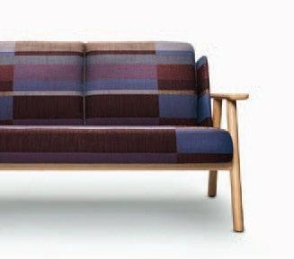  Structured Stripe | Cleaning with Bleach  Bleach can be an effective disinfectant when used properly and diluted according to the care instructions for each textile. Over 30 of Luum’s products are bleach- cleanable using a diluted bleach solution in three easy steps: Dilute, Clean and Rinse.  Coated Upholstery  Decoy, Fine Grain, Meta Texture, Monotex, Perilune, Synaptic, Top Coat, Touch Tone, Ultra Durable, Welded  Woven Upholstery  Amalgam, Biotope, Bitstream, Disrupt, Doyenne, Duo Chrome, Ephemera, Flexagon, Formwork, Geoglyph, Grid State, Haptic, High Frequency, Intone, Line Language, Macrotweed, Marl Cloth, Megapixel Modulus, Outpress, Particulate, Pebble Melange, Point Set, Point to Point, Schema, Soft Static, Spectral Array, Structured Stripe, Substance, Thangka, Tilt Shift Redux, Twisted Tweed, Two Tone, Vector, Vital, Waveﬁeld  Wrapped Wall and/or Panel  Biotope, Bitstream, Duo Chrome, Emit, Fleck Forge, Formwork, Grid State, High Frequency, Impasto, Impression, Lustrado, Intone, Marl Cloth, Outpress, Stratiform, Structured Stripe  Direct Glue Wallcovering  Dhurga, Fleck Forge, Graticule, Impasto, Impression, Juxtapose, Mica Shift, Rhetoric, Soft Ridge  Screens  Amalgam, Biotope, Bitstream, Disrupt, Doyenne, Duo Chrome, Emit, Flexagon, Formwork, Grid State, High Frequency, Intone, Lustrado, Marl Cloth, Outpress, Soft Static, Structured Stripe, Substance, Vector, Vital
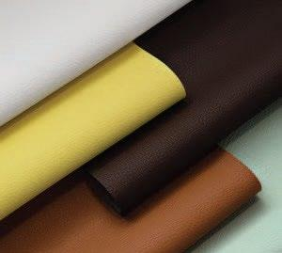  Top Coat | Antimicrobial  According to the Association of Contract Textiles, an antimicrobial ﬁnish is a chemical treatment applied to a fabric to combat growth of disease-causing microbes, general bacteria, infectious diseases, and various targeted organisms.  An anti-microbial ﬁnish on a textile inhibits the growth of bacteria but does not kill it. Antimicrobials also do not inhibit or kill the growth of viruses.  Antimicrobial products used on textiles are regulated by the EPA as pesticides. Luum promotes healthy environment, and as such, we do not promote the use of topical antimicrobial ﬁnishes.  In lieu of added antimicrobial ﬁnishes, Luum promotes the use of silicone products. Silicone, by its nature, does not support microbiological growth. Silicone is easily cleanable with soap and water, is bleach cleanable and can also be disinfected with healthcare grade wipes and sprays. Please see “Care of Silicone Upholstery” on our website.
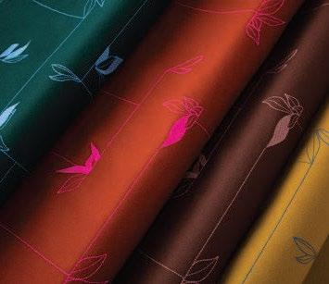  Second Nature | Sanitizing with Isopropyl Alcohol  While bleach and water solutions have been shown to be effective sanitizers, the use of Isopropanol solutions may be a gentler method of sanitizing without the potential human health irritants of bleach. Over 80 Luum products can be sanitized using 70% isopropyl alcohol and 30% puriﬁed water solutions.  Always take the proper safety precautions, read all instructions carefully and follow the label directions for safe, effective use. **Many isopropyl alcohol sanitizers also contain Quaternary Ammonium. These listings are intended for the use of products that contain isopropyl alcohol and water ONLY**  Coated Upholstery  Color Fuse, Decoy, Fine Grain, Monotex, Meta Texture, Perilune, Synaptic, Top Coat, Touch Tone, Ultra Durable, Welded  Woven Upholstery  Actuate, Adage, Amalgam, Ample, Arc Angle, Barberpole Basket, Beaded Stripe, Biotope, Bitstream, Complect, Complement, Construct, Contrast Slub, Cross Dye, Crossgrain, Cult Classic, Digi Tweed, Disrupt, Doyenne, Duo Chrome, Elastic Wool, Emergent, Ephemera, Everyday Boucle, Fleece, Flexagon, Formwork, Full Wool, Fundamentals, Flex Wool, Geoglyph, Graph Speck, Graviton, Grid State, Heather Felt, Heather Tech, High Frequency, Homage, Interstice, Intraweb, Intone, Knurl, Limitless Loop, Line Language, Macrotweed, Magnify, Marl Cloth, Megacheck, Megapixel, Melange Check, Miami, Milieu, Modulus, Navigate, Oeuvre, Outpress, Particulate, Pebble Melange, Percept, Point Set, Point to Point, Rubric, Scale Factor, Schema, Second Nature, Situ, Soft Static, Spectral Array, Stimuli, Structured Stripe, Subdivide, Substance, Super Shearling, Superspun, Texture Map, Two Tone, Vector, Velvet Underground, Vital, Wool Fleck  Wrapped Wall and/or Panel  Actuate, Artopia, Bandeau, Beeline, Biotope, Bitstream, Boucle Grid, Brazil, Complect, Complement, Cross Dye, Crossgrain, Cult Classic, Datatown, Digi Tweed, Duo Chrome, Emit, Essentials, Egypt, Flicker, Formwork, Graviton, Grid State, Heather Felt, Heather Tech, High Frequency, Homage, Impasto, Impression, India, Limitless Loop, Linen Weave, Lustrado, Makah, Marl Cloth, Megacheck, Meme, Nitty Gritty, Oeuvre, Outpress, Particulate, Percept, Peru, Presse, Rationale, Stratiform, Strio, Tangle, Texture Map, Topology, Twining, Vista, Wales, Warp Speed, Wired  Direct Glue Wallcovering  Datatown, Dhurga, Fleck Forge, Focal Point, Graticule, Impasto, Impression, Mica Shift, Rhetoric, Soft Ridge, Strio, Telecity, Twining  Screens  Actuate, Amalgam, Ample, Artopia, Bandeau, Beaded Stripe, Beeline, Biotope, Bitstream, Boucle Grid, Brazil, Complect, Complement, Cross Dye, Crossgrain, Cult Classic, Datatown, Digi Tweed, Disrupt, Doyenne, Duo Chrome, Emit, Essentials, Egypt, Fleece, Flicker, Flexagon, Formwork, Full Wool, Fundamentals, Graviton, Grid State, Heather Felt, Heather Tech, High Frequency, Homage, India, Interstice, Intone, Linen Weave, Lustrado, Magnify, Makah, Marl Cloth, Megacheck, Meme, Miami, Nitty Gritty, Oeuvre, Outpress, Particulate, Percept, Peru, Presse, Rationale, Situ, Soft Static, Stimuli, Stratiform, Structured Stripe, Substance, Superspun, Tangle, Texture Map, Topology, Twining, Vector, Vista, Vital, Wales, Warp Speed, Wired Up  Drapery  Cult Classic, Backdrop, Newknit, Gaze
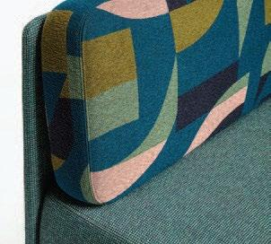  Schema | Sanitizing with Hydrogen Peroxide  Sanitizing with Hydrogen Peroxide Based Products  Hydrogen peroxide based products can be an effective alternative to sanitizing with chlorine-based bleach. Many healthcare grade “wipes” type products contain hydrogen peroxide as the active ingredient. Over 80 Luum products can be sanitized using products containing Hydrogen Peroxide. **As always, read ingredient labels carefully. These listings are intended for the use of products that contain Hydrogen Peroxide and water ONLY.**  Coated Upholstery  Decoy, Fine Grain, Meta Texture, Monotex, Perilune, Synaptic, Top Coat, Touch Tone, Ultra Durable, Welded  Woven Upholstery  Actuate, Amalgam, Beaded Stripe, Bitstream, Complect, Complement, Cross Dye, Crossgrain, Cult Classic, Digi Tweed, Disrupt, Doyenne, Ephemera, Elastic Wool, Flexagon, Flex Wool, Fundamentals, Grid State, Heather Felt, Heather Tech, High Frequency, Intone, Line Language, Macrotweed, Magnify, Marl Cloth, Megapixel, Miami, Modulus, Outpress, Percept, Point Set, Point to Point, Schema, Situ, Soft Static, Stimuli, Subdivide, Substance, Superspun, Two Tone, Vector, Vital  Wrapped Wall and/or Panel  Actuate, Artopia, Bandeau, Beeline, Bitstream, Boucle Grid, Brazil, Complect, Complement, Cross Dye, Crossgrain, Cult Classic, Digi Tweed, Egypt, Emit, Essentials, Flicker, Grid State, Heather Felt, Heather Tech, High Frequency, India, Intone, Linen Weave, Lustrado, Makah, Marl Cloth, Meme, Nitty Gritty, Outpress, Percept, Peru, Presse, Rationale, Stratiform, Strio, Tangle, Topology, Twining, Vista, Wales, Warp Speed, Wired Up  Direct Glue Wallcovering  Datatown, Dhurga, Fleck Forge, Graticule, Mica Shift, Rhetoric, Soft Ridge, Strio, Telecity, Twining  Screens  Actuate, Amalgram, Artopia, Bandeau, Beaded Stripe, Beeline, Bitstream, Boucle Grid, Brazil, Complect, Complement, Cross Dye, Crossgrain, Cult Classic, Datatown, Digi Tweed, Disrupt, Doyenne, Egypt, Emit, Essentials, Flexagon, Flicker, Fundamentals, Grid State, Heather Felt, Heather Tech, High Frequency, India, Intone, Linen Weave, Lustrado, Magnify, Makah, Marl Cloth, Meme, Miami, Nitty Gritty, Outpress, Percept, Peru, Presse, Rationale, Situ, Soft Static, Stimuli, Stratiform, Substance, Superspun, Tangle, Topology, Twining, Vector, Vista, Vital, Wales, Warp Speed, Wired Up  Drapery  Backdrop
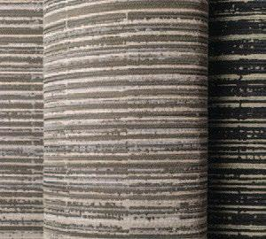  Line Language | Sanitizing with Quaternary Ammonium  Over 50 Luum products can be sanitized using products containing Quaternary Ammonium. Many healthcare grade sanitizing products contain Quaternary Ammonium as the active ingredient. It is important to read the product directions to ensure that it is speciﬁed for use on soft or porous surfaces. Quaternary Ammonium products can have a negative effect on human health and surfaces. Our recommendation is to use the gentlest sanitizers ﬁrst, before using products containing Quaternary Ammonium. **As always, test products in an inconspicuous area ﬁrst and always rinse with clean water.**  Coated Upholstery  Decoy, Fine Grain, Meta Texture, Monotex, Perilune, Synaptic, Top Coat, Touch Tone, Ultra Durable, Welded  Woven Upholstery  Beaded Stripe, Bitstream, Cross Dye, Disrupt, Flexagon, Fundamentals, Grid State, High Frequency, Line Language, Marl Cloth, Megapixel, Miami, Modulus, Outpress, Point Set, Point to Point, Soft Static, Stimuli, Subdivide, Substance, Two Tone, Vector, Vital  Wrapped Wall and/or Panel  Bandeau, Beeline, Bitstream, Boucle Grid, Brazil, Cross Dye, Datatown, Egypt, Emit, Essentials, Flicker, Grid State, High Frequency, India, Linen Weave, Lustrado, Makah, Marl Cloth, Meme, Nitty Gritty, Outpress, Peru, Presse, Stratiform, Strio, Twining, Vista, Wired Up  Direct Glue Wallcovering  Datatown, Dhurga, Fleck Forge, Graticule, Mica Shift, Strio, Telecity, Twining  Screens  Bandeau, Beaded Stripe, Beeline, Bitstream, Boucle Grid, Brazil, Cross Dye, Datatown, Disrupt, Egypt, Emit, Essentials, Flexagon, Flicker, Fundamentals, Grid State, High Frequency, India, Linen Weave, Lustrado, Makah, Marl Cloth, Meme, Miami, Nitty Gritty, Outpress, Peru, Presse, Soft Static, Stimuli, Stratiform, Substance, Twining, Vector, Vista, Vital, Wired Up

